HealthSolutions SRS document

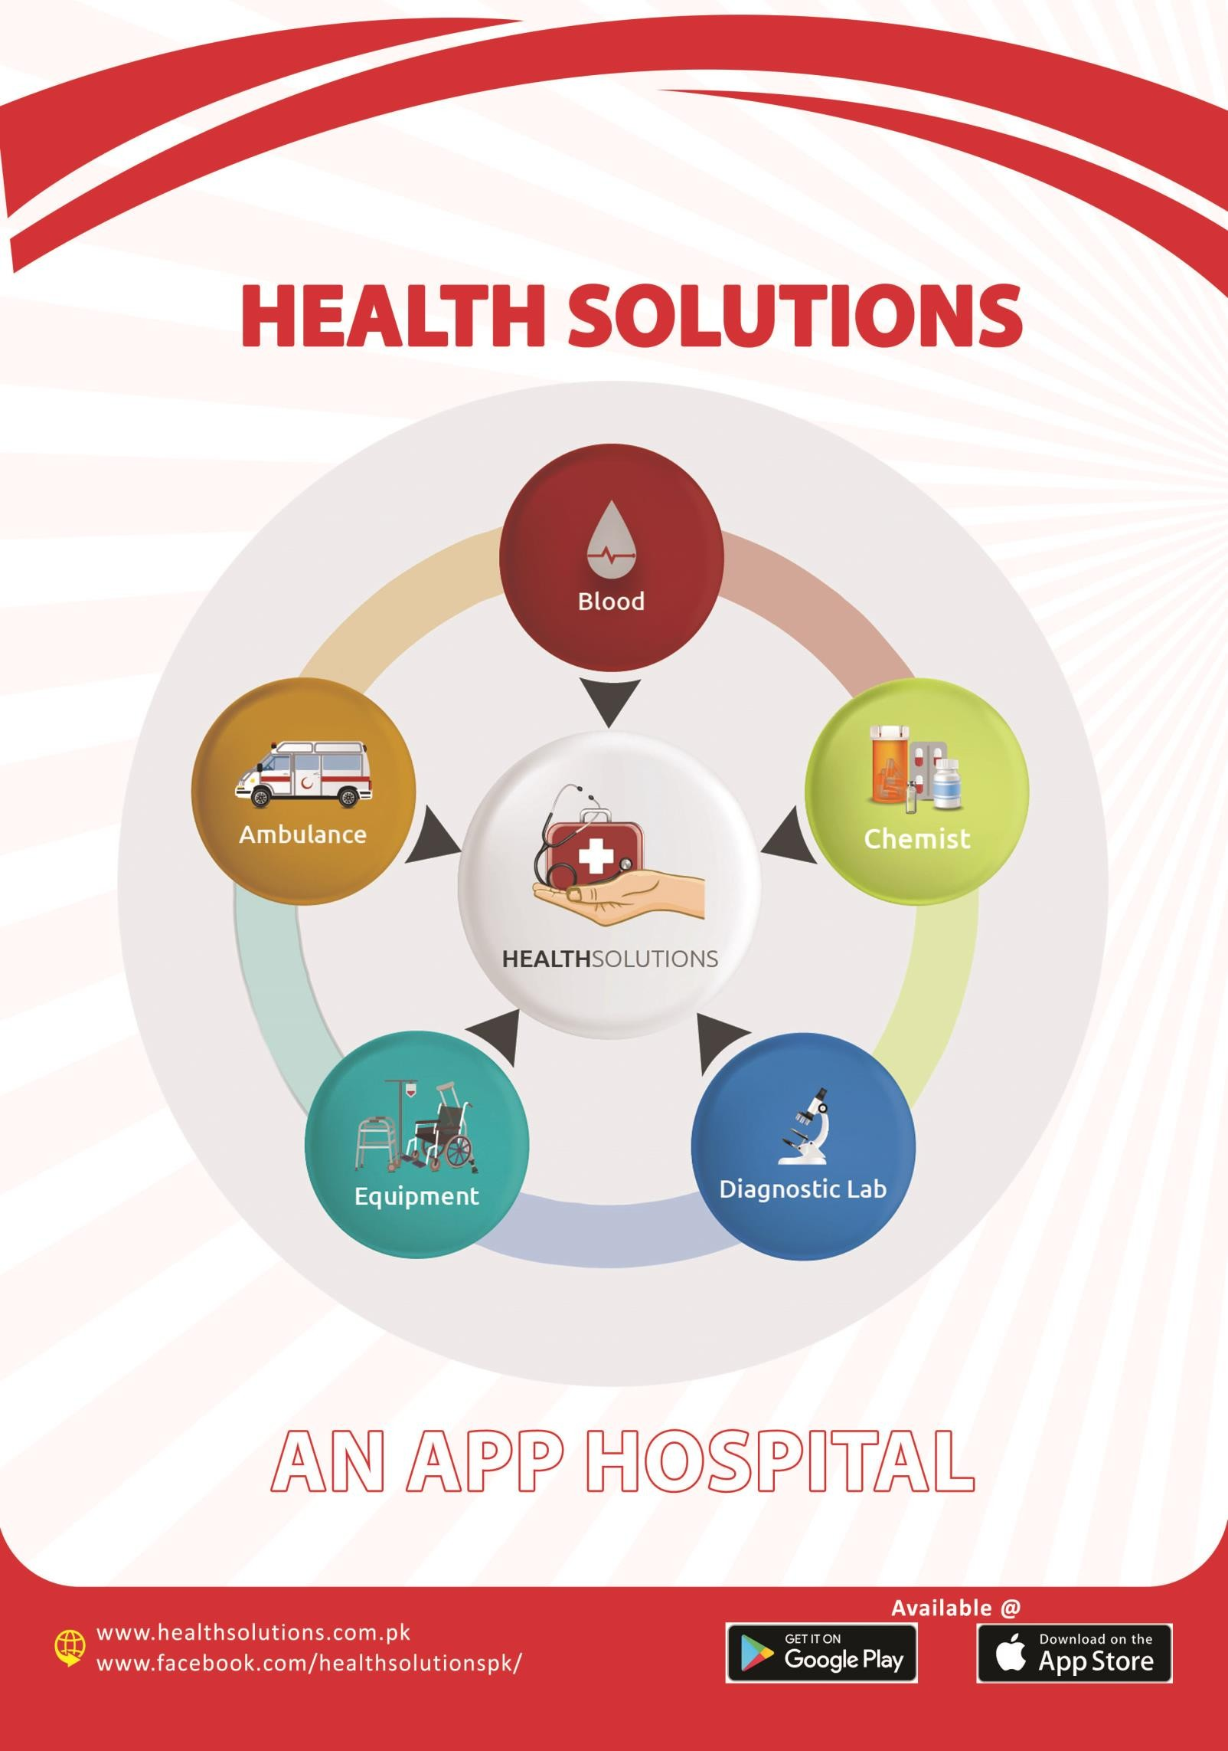

7/29/2020

Engitech Services (Pvt.) Ltd.

Prepared by: Muhammad Hamza Zubair

**Health Solutions Software requirements specification (SRS) document**

* **Introduction:**

HealthSolutions, an app, to support the humanity in such critical scenarios, has been launched voluntarily by Engitech. Our team will be delivering Healthcare and blood products and such other required items to your doorstep.  
  
HealthSolutions is a platform to merge the efforts of famous NGOs, blood banks, pharmaceutical resources, and generous blood donors in order to assist people in need of blood, medicines or ambulance.

* 1. **Ambulance with Tracking:**

HealthSolutions App provides a way to use the limited resources SMARTLY and overcome the patient transportation issues and save lives at maximum level.  
HealthSolutions App works like Uber and Careem and provides tracking with the help of which:-  
1. Multiple resources are not assigned at single LOCATION  
2. The attendant can easily track and view the Ambulance position  
3. Nearest resource is assigned to save life and time with an empowered command and control Centre monitoring multi-level Ambulances like transport, lifesaving and Advance care with Vent/minor OT working on ground through tracking and connectivity directly with the help of Artificial intelligence who defined who required which type of ambulance care. It also avoid of misusing the facility like one need the ambulance he called almost all ambulances companies and many will be on road just to pick one but using HealthSolutions App when it connected with one rest will automatically available for other requirements.

* 1. **Blood:**

Currently getting blood is difficult in lot of cases due to situations like non-availability of Donor(s), non-availability of of Blood product in specific Blood Bank etc. Health solution offers Blood without Donor via rider to the location where you need.

There are four facilities available in Blood module:

1. Request blood
2. Donate blood
3. Request plasma
4. Donate plasma
   * 1. Request Blood:

The user can request blood by entering all the requirements in the “Blood Request” form. The blood request form will have the following fields:

1. Location
2. Blood group
3. Date (Require before)
4. Blood Product and quantity

After filling and submitting the form, the blood request email will be received to healthsolutions support team.

The delivery fee for the blood request is Rs. 550 PKR

* + 1. Donate Blood:

HealthSolutions also provides a platform for the blood donors to donate blood. The donors who want to donate blood can do blood donate request. The “Donate blood” request form has the following fields:

1. Location
2. Blood group
3. Date of birth
4. Weight
5. Gender
6. Schedule appointment
7. Last donation date

After submitting request, a conformation message will be displayed and an email will be sent to the support team.

* + 1. Plasma request:

The user can also request for plasma from the “Request Plasma” section. The request plasma form has the following fields:

1. Location
2. Blood group
3. Require before

After submitting the request, a confirmation message will be displayed and an email will be sent to the support team.

2.1.4 Plasma Donate:

The user can also donate plasma by doing plasma donate request. The plasma donate request form has the following fields:

1. Location
2. Blood group
3. Date of birth
4. Weight
5. Gender
6. Schedule appointment
7. Last donation date

After submitting the form, a confirmation message will be displayed and an email will be sent to the support team.

* 1. **Chemist:**

Getting specific medicines at different locations of the city is almost impossible which is overcome by HealthSolutions having a network of pharmacies and the medicines are delivered at the doorstep of the user within the same day.

There are multiple options available for the users to do an order in Chemist section:

1. Order by prescription
2. Order by search or Shop online
3. Write your order
   * 1. Order by prescription:

There is an option to upload the prescription image in this section. At first, the user uploads the prescription image, after uploading the image, a form will be opened having the following fields:

1. Address
2. Image
3. Shipping charges (Rs. 200 PKR)

After placing order, a confirmation message will be displayed and an email will be sent to the support team.

* + 1. Order by search:

It’s an e-commerce section where users can buy chemist products. This section has the following fields:

1. The product list
2. Add to cart screen (The products that are added to cart will be displayed on this screen)
3. Place order screen. Having the following fields:
4. Address (Mandatory)
5. Prescription image (Optional)
6. Shipping Charges (Rs. 200 PKR)
7. Check out screen (Displaying the list of ordered products and total bill)
8. Payment method screen (Cash, Credit card, Bank transfer)

The user can select any payment method. After payment, the order email will be sent to the support team.

* + 1. Write your order:

This section contains a form having the following fields:

1. Name
2. Email
3. Phone
4. Write your order (The user can write his order requirements in this section)

On submitting the request, a confirmation message will be displayed and an email will be sent to the support team.

* 1. **Diagnostic Lab:**

Visiting to a Diagnostic center is not easy in the current traffic situation of the city. HealthSolutions solved this problem by adding solution to send Phlebotomist to the doorstep of the user. reports are also delivered to the doorstep as well as available in the app to view.

This section has the following options:

1. Order by search
2. Order by prescription
3. View reports
   * 1. Order by search:

This section has the following fields:

1. Location
2. Prescription image
3. Select time
4. Test name window
5. Add test (On clicking on this option, a window will be opened having a search box. The user can search for their required diagnostics test, on entering the name of the test, a drop down list will be opened from which the user can select the test. The selected tests will be displayed in the “Test name” window)

On submitting the request the user will be proceed to the check out screen, displaying the list of selected tests and total bill. After checkout, the payment method selection screen will be opened having the following payment methods:

1. Cash
2. Credit card
3. Bank transfer (This method contains an option to upload the bank receipt image and shows the IBAN: “PK63ABPA0010031198440020”. The user will submit the request after uploading the bank receipt image.

After payment, emails will be sent to support team and user having the order details.

* + 1. Order by prescription:

This section has the following fields:

1. Location
2. Prescription image
3. Select time

On submitting the request, a confirmation message will be displayed and an email will be sent to the support team and the user.

4.1.3 View reports:

In this section, all the reports will be displayed that are sent to the user by the support team.

* 1. **Equipments:**

There are two options in this section:

1. Equipment to buy
2. Equipment on rent
   * 1. Equipment to buy:

This section contains a form having the following fields:

1. Name
2. E-mail
3. Phone
4. Write your requirements

After filling the form and submitting the request, a confirmation message will be displayed and an email will be sent to the support team and user. The email that goes to support will have the subject line as “Equipment to buy”.

* + 1. Equipment on rent:

This section contains a form having the following fields:

1. Name
2. E-mail
3. Phone
4. Write your requirements section (The user can write his requirement in this field)

After filling the form and submitting the request, a confirmation message will be displayed and an email will be sent to the support team and user. The email that goes to support will have the subject line as “Equipment on rent”.

* 1. **Fitness:**
  2. **General physician**

Online Consultancy lets you seek medical advice and guidance from best doctors of different specialties at your own home. You can also get first aid through a doctor 24/7. It is the most convenient way to consult a doctor if you have a busy schedule and cannot visit doctor or live in a remote area.

This segment has the following features and functionalities:

1. Departments selection
2. Doctors list
3. Nearby doctors list
4. Recommended doctors list
   * 1. Departments selection:
5. This section will display all the departments or specialties. The user can search for the doctors according to their desired specialty by selecting any department from this list. The doctors with the respective specialty will be searched and displayed.
6. On clicking on “View All” button, all the departments will be displayed in a grid view
   * 1. Doctors list:
7. In this section, all the available doctors will be displayed. The user can book the doctor of his choice.
8. On clicking on “View all” button, a screen will be opened having two sections, “Online doctors” and “Doctor list”. The doctors which are online will be displayed in the “Online doctors” section and all the doctors will be displayed in the “Doctor List” section. The following details of the doctor will be displayed in the home screen and doctor list corresponding to each doctor.

* Doctor’s name
* Specialty
* Degree
* Consultancy charges
* Consultancy timings
* Doctor’s rating

On clicking on the book button, a booking screen will be opened. The form will have the following fields:

* Write details regarding your symptom or any previous reports or medicines.
* Full name
* Gender
* Age
* Previous doctor (Optional)
* Previous reports/Medicans (Optional)

This field has the option to upload two images. The user can upload the images of his previous reports if he wants.

* Description (The user needs to enter the description of the illness)

After filling this form and clicking on the “Next button”, the user will be moved to the next screen having the following details and options.

* Doctor’s info (Doctor name, specialty, Degree, Experience, Rating, Doctor’s availability days)
* Calendar:

1. The days in which doctor is available will be displayed as enabled (Highlighted)
2. The days in which doctor isn’t available will be displayed as disabled (Non-highlighted)
3. The days in which the doctor is available but not available in some dates of it (Off dates) will also be displayed as disabled (Non-highlighted)
4. The user can only book appointment for the next four months from the current month.
5. If user tries to book an appointment for the disabled dates than a message should be displayed as, “The doctor is available on “Names of the days in which doctor is available”.
6. If user selects any date from the calendar in which the doctor is available than a list of doctor’s available time slots will be opened. Each time slot will be of 15 minutes.
7. The user can select any of the available time slots
8. If the selected time slot has already passed than a message should be displayed as, “The selected time slot has passed, please select another one from the available slots”.
9. The time slots that have already been booked will be displayed as disabled and if user selects that time slot than a message should be displayed as, “This time slot has already been booked”
10. On selecting any date from the doctor’s available days, selecting a time slot that is not already registered and has not passed and clicking on the “Book an appointment” button, the user will be moved to the next page i.e Payment method screen having the following payment methods:

* Credit card (If user selects this option, a credit card payment gateway will be opened and an email will be sent to the support team and user having all the appointment details)
* Bank transfer (This method contains an option to upload the bank receipt image and shows the IBAN: “PK63ABPA0010031198440020”. The user will submit the request after uploading the bank receipt image.

After payment, emails will be sent to support team and user having the appointment details.

In this section there is also a filter option to sort the doctors of your choice having the following filter options:

* Date ( On selecting this option, a calendar will be opened and the users can select any date of their choice to filter)
* Popularity (Doctor’s rating)
* Senior (Experience)
* Distance (From the user’s current location)
* Price (“Free” or “Paid”)

On selecting the desired filter options and clicking on the “Apply” button, the sorted list of doctors will be displayed.

* + 1. Nearby doctors list:

In this section, all the doctors will be displayed that are within a radius of 25 km. On clicking on “View all”, screen will be opened displaying all the nearby doctors available on the map a long with their distance from the current location. A list of all the nearby doctors will also be displayed on this screen having the following doctor details:

* Specialty
* Timings
* Distance in Km (From the current location)
* Book
* See on map (If a user clicks on this option than the user will be moved to that particular doctor’s location on the map.
* If a user selects any doctor from the map than he will be moved to that selected doctor and that doctor will be highlighted in the doctors list available on this screen.
  + 1. Recommended doctors list

In this section, all the doctors will be displayed having rating greater than “3.5”. The doctors will be displayed according to country/region. If the user selects country other than Pakistan, than the doctors of Pakistan won’t be displayed in this section. The list of all the recommended doctors will be displayed having the following details for each doctor:

* Doctor’s name
* Degree
* Doctor’s rating
* Timings

On clicking on “View all”, a list of all the recommended doctors will be opened. The user can book any doctor by clicking on the “Book” button.

* 1. **Home care & Nursing:**

This segment has the following options. The users can request from the following five options:

* Nursing
* Technician
* Nutritionist
* Physiotherapist
* Attendant

On clicking on any of the above options, a confirmation dialog box will be opened asking the user that “Do you want to proceed the request?” and have two options “Cancel” and “Proceed”. If the user clicks on proceed, his request will be proceed and a Home care request will be sent to the support team and a confirmation email will be sent to the user.